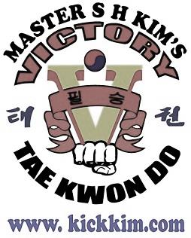
CONGRATULATIONS ON EARNING YOUR
CAMO BELT TEST INVITE!!
If you pass your test, we would like to explain the procedure on when you will use your sparring gear as well as any other topics regarding your new equipment.
When will you use your gear:
1. During Pre-Sparring week you need to wear the following to class:
- Gloves
- Fore-Arm guards
- Shin & Instep Guards
2. During Sparring Week you will need to wear the following to class:
- Gloves
- Fore-Arm Guards
- Shin & Instep Guards
- Chest Guard
- Groin Protection
- Leave Head Gear in bag
Tips:
- We HIGHLY Suggest your put your name on each piece of equipment AFTER your first class, therefore Staff/Masters can confirm the size is correct!
- Bring water to class you will need it!
- If you have any health conditions related to light contact to your chest please inform us.

If you have any question please do not hesitate to ask! GOOD LUCK and HAVE FUN!
Sincerely,
Victory Taekwondo Academy

