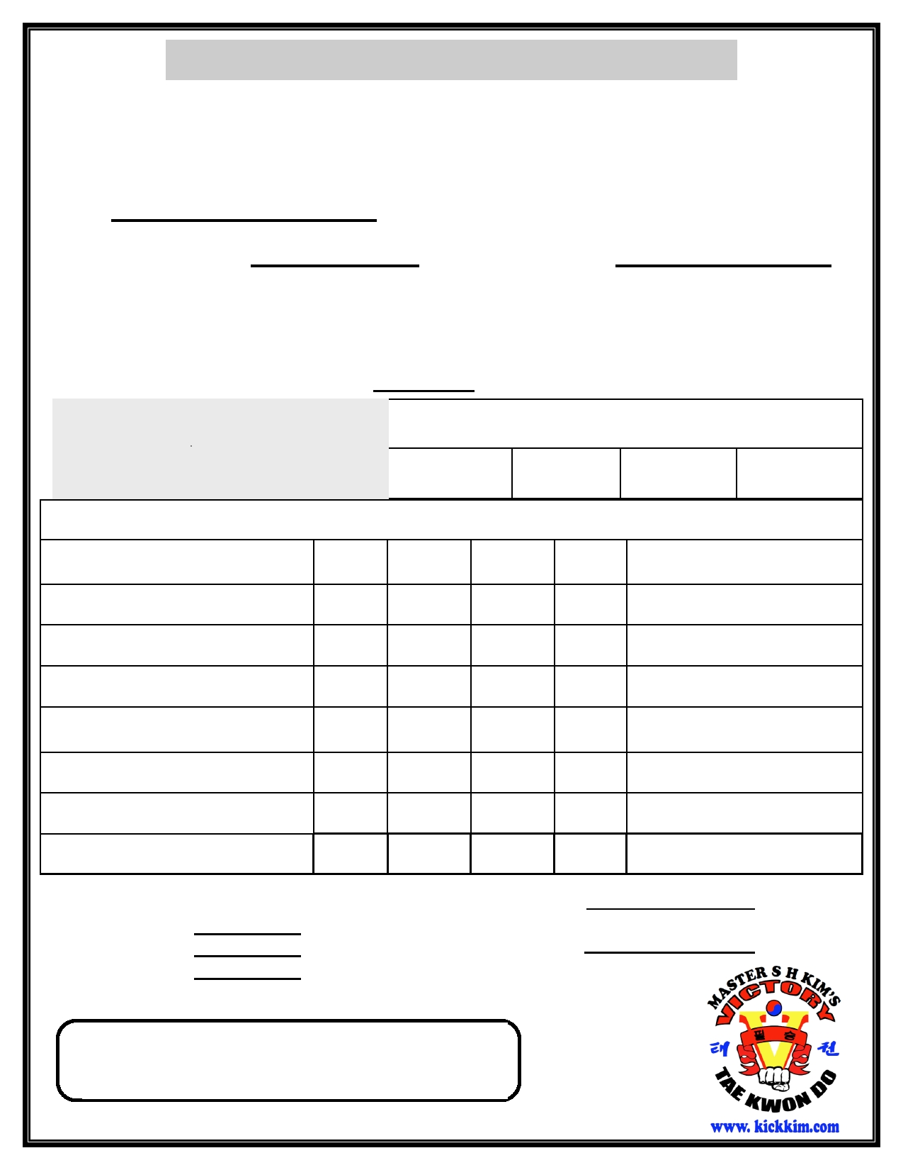
Victory Taekwondo
Victory Taekwondo

Graduation Application for Red High Belt to Bo-Dan Belt

Name: Class (circle one): Little Eagle Children Adult
Graduation Time Graduation Date 6 / 27 / 20

Attendance Rating
Class Assistant

The test fee is non-refundable, I must agree to abide by the judge's decision in
awarding or withholding promotion. I understand that failure to follow school
rules or remain a member in good standing may result in revocation of belt rank.
Initial:

Test Fee: $90 due 2 days before test
Additional: $10 Late Fee if after deadline
Make-up Testing: $100

Test Fee:
$55

due 2 days before test
Date Paid
Employee
Testing
Method of

Additional:
$10 Late Fee if after deadline
Fee
Payment

Make-up Testing: $85

Curriculum A B C D Notes
Taekeuk 7/8

Red Belt Ten Basic Motions

Sparring
Basic Kicking
Ki Hap
Confidence
Questions
Breaking

Physical Test:
Sit Up:
Push Up:
Flexibility:

Progress Meeting:

Master/Examiner:

Pass/Retest
Form Due At Least TWO Days
Form Due At Least TWO Days
Before Testing
Before Testing

- Home Behavior Report
Parents/Guardians must fill out the Home Behavior Report below. This is a part of the testing
procedure. Students who receive too many P's will not be allowed to test! We must work together for our children's future.
 | E | S | P | Notes
Homework/Studying
Listening Skills
Grooming Habits
Helping Parents/Chores
Cleaning Room
Getting Along with Siblings/Family
Practices Taekwondo
E = Excellent S = Satisfactory P = Poor

- Reading Report

How many pages have you read since your last test? +1000 or -1000 (Please Circle one)

- Top Three Testing Students
Students who try their best every class and never give up will be nominated for earning one of the Top Three Testing Student awards! We check which students not only have great technique but more importantly good listening skills, self-discipline, and always shows respect.

