Victory Taekwondo

Graduation Application for Green Belt to Purple Belt

Name: Class (circle one): Little Eagle Children Adult
Graduation Time Graduation Date 6 / 27 / 20

Attendance Rating

The test fee is non-refundable, I must agree to abide by the judge's decision in
awarding or withholding promotion. I understand that failure to follow school
rules or remain a member in good standing may result in revocation of belt rank.
Initial:

Test Fee: $55 due 2 days before test
Additional: $10 Late Fee if after deadline
Make-up Testing: $65

Early Registration: $55

due 2 days before
Date Paid
Employee
Method of
payment
Testing
Fee

Additional: $10 Late Fee if after deadline

Make-up Testing fee:

Curriculum
Taekuek 3/4/5/6
Green Belt 10 Basic Motions
$65

A

B

C

D

Notes

Sparring
Basic Kicking
Ki Hap
Confidence
Questions
Breaking

Physical Test:
Sit Up:
Push Up:
Flexibility:

Progress Meeting:

Master/Examiner:

Pass/Retest
Form Due At Least TWO Days
Before Testing

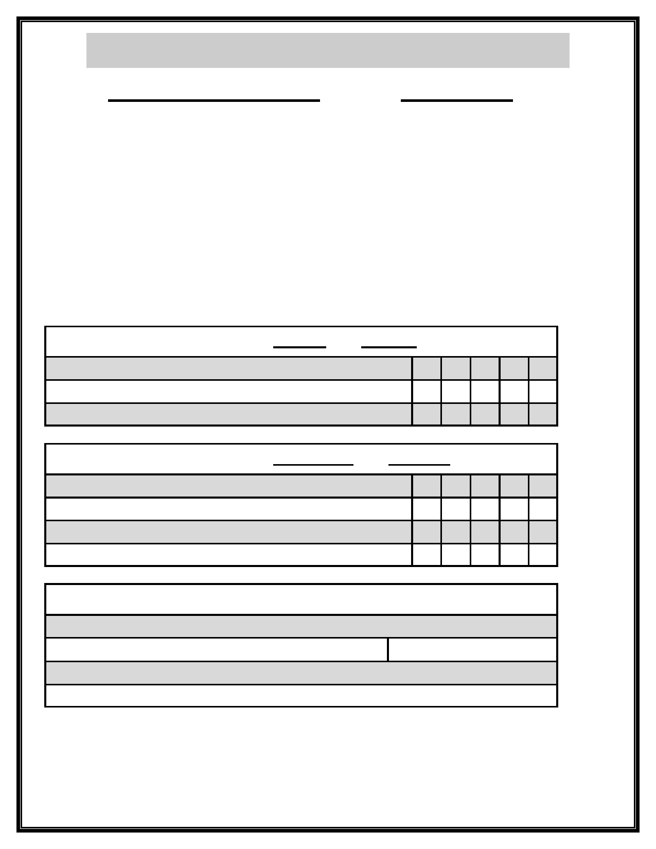
Graduation Application for green Belt to Purple Belt

Name: Age:

As part of the testing procedure you must complete a one (1) page essay. The essay should
be typed on a separate sheet of paper and stapled to the upper left hand corner. The essay
should be handed in by the testing deadline. Please make sure to include your name, cur-
rent belt level, and age on the top of the essay.

Essay Questions:
1. Define the meaning of confidence.
1. Define the meaning of concentration.
2. How does having good concentration help you in your everyday life?
3. How has TaeKwonDo helped you improve your concentration?
2. How has confidence helped you become a leader in your everyday life?
3. What life goals have you achieved since you started your

Please rate the following questions from very little (1) to quite a lot (5)

How much of a positive influence has TKD had on your life? 1 2 3 4 5
How much has TKD helped you outside of TKD class? 1 2 3 4 5
How much do you think TKD has made you a better person? 1 2 3 4 5

Please rate the following questions from not often at all (1) to all the time (5)

How often do you do acts of kindness for others? 1 2 3 4 5
How often do you take time for yourself? 1 2 3 4 5
How often do you practice TKD outside of TKD class? 1 2 3 4 5
How often do you eat healthy meals? 1 2 3 4 5

Please answer the following:

How many glasses of water do you drink per day?
How many servings of fruit to you eat per day? Vegetables?
How many hours of exercise do you do per week?
How many hours of community service do you do per month?

How many pages have you read since your last test? +1000 or -1000

